Certificate of Analysis

General properties:
Name：MAL-PEG3400-PLA2000，(PLA,DL型)
Molecular Weight： PEG, MW:3400 PLA,MW:2000
Cat.#： R-D-12002
Lot.#： 854515
Manufacture Date： 2016.01.20
Date of Analysis： 2016.01.20
Recommended Retest date： 2017.01.20
Stability： 12 months
Storage： -20°C in the dark

Structure

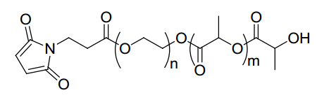

Items | Specification | Results
Appearance | White/ Off-white solid | White solid
¹H NMR | Identical to the structure | Identical to the structure
Foreign Material | None | None
Substitution | ＞90% | 91%
Report Date: 2016.01.20

核磁图谱：

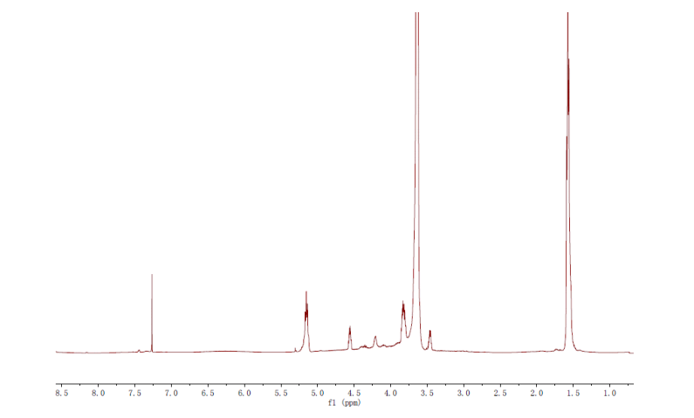

This product is for research use only, Not for human or animal use

