Certificate of Analysis

General properties:
Name： Cy7-PEG2000-NH2
Molecular Weight： 2000 Dalton
Cat.#： R-9963
Lot.#： RCN160510
Manufacture Date： 2016.05.10
Date of Analysis： 2016.05.10
Recommended Retest date： 2017.05.10
Stability： 12 months
Storage： -20°C in the dark

Structure

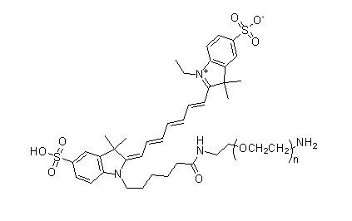

Items | Specification | Results
Appearance | Blue solid | Blue solid
¹H NMR | Identical to the structure | Identical to the structure
Foreign Material | None | None
Substitution | ＞90% | 90%
Report Date: 2016.05.10

This product is for research use only, Not for human or animal use

