Certificate of Analysis

General properties:
Name： FA-PEG2000-NH2 (叶酸聚乙二醇氨基)
Molecular Weight： 2000 Dalton
Cat.#：R-99133
Lot.#：RF201605004
Manufacture Date： 2016.05.04
Date of Analysis： 2016.05.04
Recommended Retest date： 2017.05.04
Stability： 12 months
Storage： -20°C in the dark

Structure

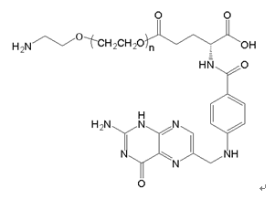

Items | Specification | Results
Appearance | Yellow solid | Yellow solid
¹H NMR | Identical to the Structure | Identical to the Structure
Foreign Material | None | None
Purity | ＞80% | 90%
Report Date: 2016.05.04

This product is for research use only, Not for human or animal use

