Certificate of Analysis

General properties:
Name： FITC-PEG400-Alkyne
Molecular Weight： 800 Dalton
Cat.#： R-9939
Lot.#： RF201605006
Manufacture Date： 2016.05.06
Date of Analysis： 2016.05.06
Recommended Retest date： 2017.05.06
Stability： 12 months
Storage： -20°C in the dark

Structure

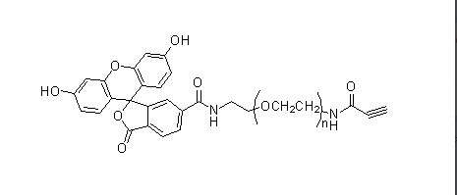

Items | Specification | Results
Appearance | Red solid | Red solid
¹H NMR | Identical to the structure | Identical to the structure
Foreign Material | None | None
Substitution | ＞90% | 90%
Report Date: 2016.05.06

This product is for research use only, Not for human or animal use

