Certificate of Analysis

General properties:
Name： DSPE-PEG2000-半乳糖
Molecular Weight： 2000 Dalton
Cat.#： R-9957
Lot.#： RG0162061
Manufacture Date： 2016.06.20
Date of Analysis： 2016.06.20
Recommended Retest date： 2017.06.20
Stability： 12 months
Storage： -20°C in the dark

Structure
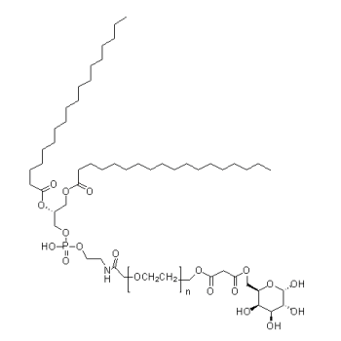

Items | Specification | Results
Appearance | White/ Off-white solid | White solid
¹H NMR | Identical to the structure | Identical to the structure
Foreign Material | None | None
Substitution | ＞90% | 90%
Report Date: 2016.06.20
This product is for research use only, Not for human or animal use

